**CS-230 Software Engineering**

A1 Object-Oriented Design Document

**2.1.1 Candidate Classes and Responsibilities**

|  |  |
| --- | --- |
| **Player** | |
| Responsibilities | Collaborators |
| inventory (Holds the tokens, keys and other items) | Cell  Collectables  Level  Enemies  LevelSelect |
| Restart Check (If Player lands on a kill cell then new instance of player (resetting inventory) (in Profile) |
| goal (ends the game to then be presented with |
| move (manipulation of direction and cell moves within level it will check what cell the next move will land on then run that event (teleport etc.) |

Player-This will hold the attributes that the player holds to use within each level, it will respond to different events like teleportation, goal, kill calls, doors etc.

(Subclass of Moveable) (Author- Ciara and Bryony)

|  |  |
| --- | --- |
| **Profile** | |
| Responsibilities | Collaborators |
| Current Level (Based on levels completed (linked list implementation)) | Level  LevelSelect  MainMenu |
| Store Name of profile |
| Hold save (Holds the save file of the player that has left midway through the game) |

Profile- These are the instances of profiles that users will have to record their current progress in the level, along with their high scores. There will be multiple instances of Profile so that users can compete against each other for the highest score. This could also be used if we were going to save progress of a level if the user quit before finishing, as we could save their current location and attributes to the Profile for when they log back on.

(Own Class) (Author- Ciara and Johannes)

|  |  |
| --- | --- |
| **Cell** | |
| Responsibilities | Collaborators |
| Abstract Class all cell types inherit from cell cords/location (x , y) linked list | MapReader  Moveable |
| Adjacent Cells (north, east, south, west) |
| Cell Type (The type of cell) |
| Is cell solid (can it be walked though for enemies, players can go to individual classes that inherit from cell to see if they meet criteria to pass) |

Cell- This an abstract class that will hold all the different cell types, it mainly holds the type and the position as well as adjacent cells.

(Super class of Ground and Wall) (Author- Ruth and Jake)

|  |  |
| --- | --- |
| **Smart Enemies** | |
| Responsibilities | Collaborators |
| Position (holds the position of itself) | Level  Player  Cell |
| Player Position (holds the players current position (gets from level class)) |
| Shortest Route (Calculates shortest route from its current position to players position) |
| move (moves into the next cell only if it isn’t wall cell for inherited enemy class) |
| If no path available to player, then moves to random valid cell |

Smart Enemies-This class will only hold the characteristics of the smart enemy, as it’s a subclass of Enemies. Its main function is to move along the shortest route possible to the player so that it can kill it.

(Sub Class of Enemies (Subclass of Moveable)) (Author- Tom and Rohini)

|  |  |
| --- | --- |
| **Level** | |
| Responsibilities | Collaborators |
| Level Name (e.g. level1) | LevelSelect  Profile  Player  Enemies  MapReader |
| Top Score (Stores the top 3 scores for each instance of level and checks that if the score has been beaten) |
| Keeps track of what is within the level and location (gets the enemies etc.) |
| Load level (this starts the time and the screen to present the level with the current positions) |
| Holds the current score and also can change the start score counter to whatever was stores if file was saved midway through level. |
| Saves player to profile every move player takes |

Level-This is the class that will hold all the data for the level, making it easy to save the current progress. It will also hold the 3 highest scores, and the locations of all the Moveables.

(Own Class) (Author- Johannes)

**2.1.2 Class Diagrams**

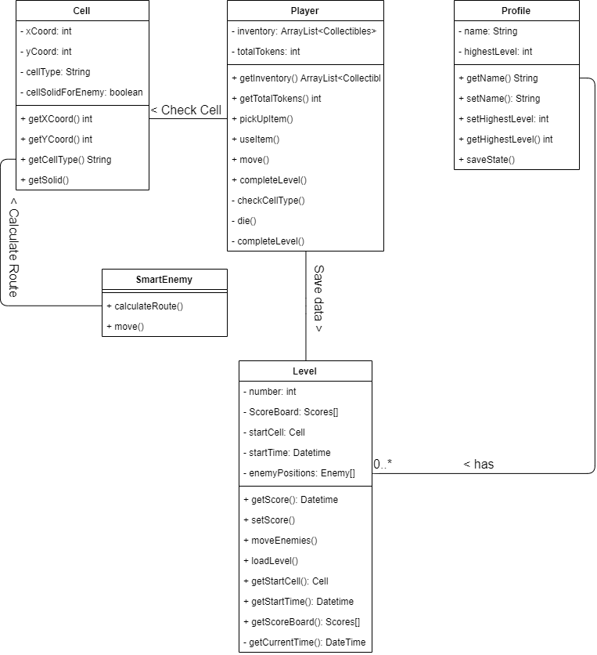

**Collaborations**

**Profile-Level –** Each instance of a profile stores the information about the completed levels. If no levels have been started, this data will be empty, and no instances of Level will be in Profile. As levels are saved/completed, the Profile will update to show if the Level is complete or not, the score, and will store this.

**Player-Level** – When the Level is saved, all the information and data about the level must be saved, such as the score and the positions of each enemy. As well as this, the player position must be saved as well as the inventory of the player.

**Player-Cell** – When moving, the player must perform a check to see if the cell that they attempt to move into is valid. The cell will then return its type and the Player class will handle the data accordingly. For example, if the player attempts to walk into a Wall cell, they will not move, as they can’t move into it.

**SmartEnemy-Cell** – To calculate the shortest route to the player, the enemy must check each cell for their type and the adjacent cells in the direction of the player to find a path. Each cell would return the relevant information until the shortest route has been found.

**Complex Behaviours**

**Calculate Route** -This method should find the shortest path between the smart enemy and the player, this should be constantly changing as player moves around the grid. This will be implemented by using the shortest path algorithm. This class will need to collaborate with player to find the player position and map reader to be able to find valid routes for the enemy to go e.g. not through walls etc.

**Load level**-This method loads in the level from the file where the game info is stored, this could be a previously saved level which is now being resumed by the player. The load method will read in the ASCII text file so it can be printed to the screen. Load game will need to collaborate with profile to produce the grid with the objects in the correct positions.

**Complete level** -call getScore to save score for the level. Clear inventory and set token total to 0. Increment HighestLevel using set HighestLevel. Display scoreboard and then level menu.

**Move** -call move up/down/left/right appropriately. Call checkCellType. Dependent on cell type call appropriate methods to use items from inventory, change coordinates or die.

**SaveState** - This is a method that will be used if the Profile exits the game midway through the level, once they exit the current level then the instance of the player will be saved to player as well as the level as you need to keep the enemies position and the tokens picked up. Saving these to profile will mean when the person goes back onto their profile, they will then be able to load their game at the currently saved place, making sure all the entities are in the same place as before so no bugs to exploit.

<EXTEND THESE IF YOU WISH, MOVE AND COMPLETE LEVEL SHOULD BE EXTENDED>

**2.1.3 Hierarchy Descriptions**

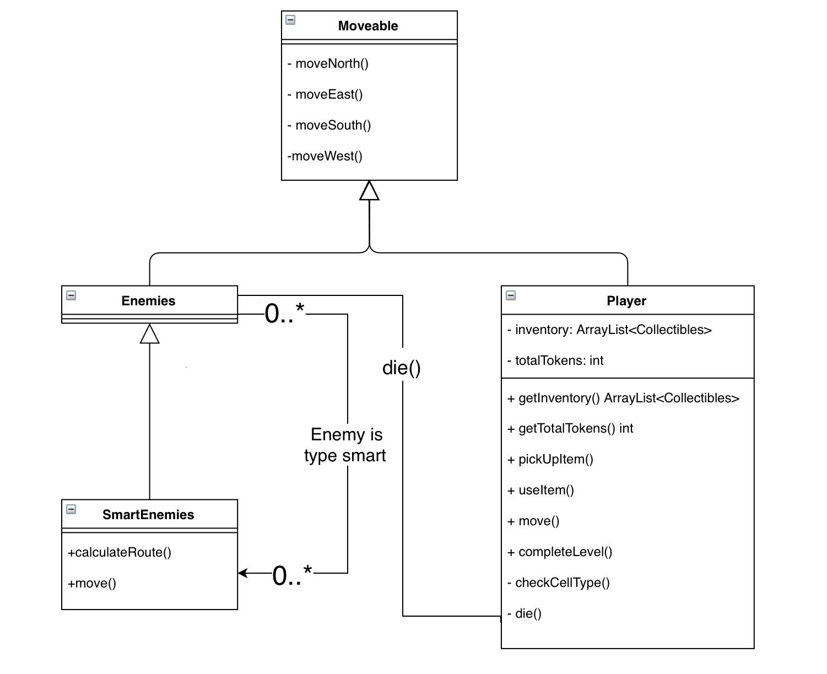

<BENEFITS OF HIERACHY AND WHY THAT DESIGN CHOICE>

**2.1.4 Level File Format**

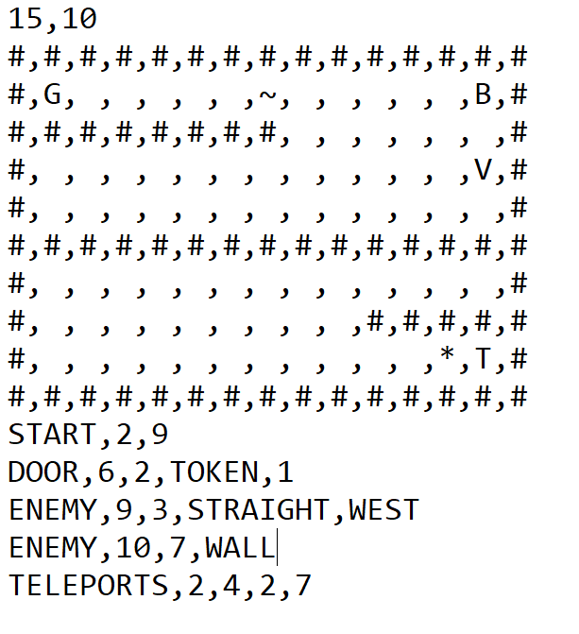 The first line of the level file defines the height and width of the map using the two comma separated values. Line 2 till line height of map+1 will be an ASCII representation of the cells on the map that do not require extra data to define.

Wall (“#”)

Water (“~”)

Goal (“G”)

Tokens (“T”)

Fire (“*”)

Flippers (“V”)

Boots (“B”)

Ground (“ “)

Ground cells are replaced by any cells that are defined later.

The next line after the map shows the start position “START” of the player, represented by two comma separated values (x and y coordinates).

After this, any extra cells that have not been defined are done so, this is done by specifying the type of cell followed by any relevant data in the comma separated list.

For door this would be “DOOR” followed by the x and y coordinates, and then the type of the door. If the type is token, the token cost comes next, otherwise the colour of the door comes next. Teleporters “TELEPORTS” are defined in pairs, with the x and y coordinates of each as the data in the list. The key is a “KEY” followed by its x and y coordinates and the colour of the key. Enemies come last, with a symbol of” ENEMY” denoting them. They have x and y coordinates followed by the type of enemy. Straight Line enemies also need the direction and something to tell what side it is following

<EXTENSION NEEDED HERE AS DOCUMENT SAYS MAXIMUM 2 PAGES AND WE HAVENT EVEN HIT ONE>